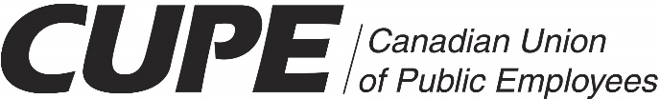
Local 4214

General Membership Meeting

Selkirk Hospital – MPR

October 25, 2016

1730 –

1. Roll Call
2. Equality Statement-Kirsten Dann
3. Initiation –Sherry

4. Reading of Minutes-Terri Conley
a) Minutes from May 16, 2016

5. Bargaining Update-Morgan Chagnon/Sherry
i) 2012-2017 CBA
ii) proposals/items on the table for bargaining

6. Secretary Treasurer’s Report-Kirsten Dann

7. Financial Business
Transfer of funds from 4593
Audit 2015

8. Local Issues
Grievances

9. Executive Board Reports and Recommendations
a) Bylaws Update-Morgan Chagnon/Sherry

10. Reports
a) PHCC(Provincial Health Care Council)-Morgan Chagnon
b) 4214 Tour-Morgan Chagnon/Kirsten Dann

11. Nominations, Elections and Installations
a) By-Election for Vice-President

12. Unfinished Business

13. New Business
Bargaining Process-Morgan Chagnon
Correspondence/Communications-Terri Conley

14. Good of the Union-Discussion

15. Adjournment

